**Instructions**: **Identify your test with your name, (last name followed by first name).** Use this WORD document to submit your test answers. I will add my comments directly to your .docx document. Enter your code solution below the problem statement along with any required output or displays. I prefer that you copy and paste results from the console. Be careful with the format of your report. Watch the margins and pagination. Depending on the problem, grading will be based on: 1) the correct result, 2) coding efficiency and 3) graphical presentation features (labeling, colors, size, legibility, etc). I will be looking for well-rendered displays. Do not print and display the contents of vectors or data frames unless requested by the problem. You should be able to display each solution in fewer than ten lines of code.

**Example Problem with Solution**: Use rbinom() to generate two random samples of size 10,000 from the binomial distribution. For the first sample, use p = 0.45 and n =10. For the second sample use p = 0.55 and n = 10.

1. Convert the sample frequencies to sample proportions and compute the mean number of successes for each sample. Present these statistics.

> set.seed(123)

> sample.one <- table(rbinom(10000, 10, 0.45))/10000

> sample.two <- table(rbinom(10000, 10, 0.55))/10000

> successes <- (seq(0, 10))

> sum(sample.one*successes)

[1] 4.4827

> sum(sample.two*successes)

[1] 5.523

1. Present the proportions in a vertical side-by-side barplot color coding the two samples.

> counts <- rbind(sample.one, sample.two)

> barplot(counts, main="Comparison of Binomial Sample Proportions",

+ ylab = "Frequency", ylim = c(0,0.3),xlab="Number of Successes",

+ beside = TRUE, col=c("darkblue","red"),legend = rownames(counts),

+ names.arg = c("0","1","2","3","4","5","6","7","8","9","10"))

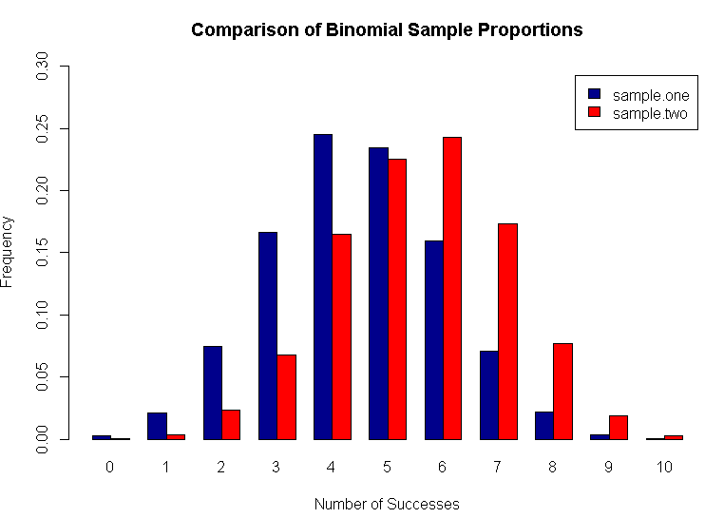

Test Questions (25 points total)

1. (3 points) Create and print a vector that contains the following in this order:

* A sequence of integers from 6 to 10 (inclusive).
* A twofold repetition of the vector c(2, -5.1, -33).
* The value of the sum of 7/42 and 2.  
  1. Extract the first and last elements of the vector you have created to form another vector using the extracted elements. Print this second vector.
  2. Form a third vector from the elements not extracted in (a). Print this vector.
  3. Use the vectors from (a) and (b) to reconstruct and print the original first vector.

1. (5 points) The expression y = a + bx + cx2 is a quadratic function.   
   1. Write a function in R that accepts values for a, b, c and x and returns a value for y.
   2. Create and save a vector, x, of 101 equally spaced values from -2 to 2 inclusive.
   3. Using the following values a = -1, b = 0, c = 1 with your function, calculate values for a vector, y, using the vector x from (b).
   4. Plot y versus x in color. Add a title to the plot and other features to this plot.
   5. Confirm the roots of the specified quadratic function are -1 and 1.
2. Use the trees data set (shown in the Quick Start Guide) for the following. This data set has three variables (Girth, Height, Volume) on 31 trees.
3. (2 points) Use apply() to present the median values for the three variables in trees. Using R and logicals, give the row number and print the three meplasurements for the tree that has a Volume measurement equal to the median Volume.

b. (2 points) Assume the Girth is the circumference of a circle. You may either use pi as   
 supplied in R as a library constant, or the value pi = 3.14159 to calculate the diameter  
 of each tree. Present a five-value summary of your results with summary().

c. (2 points) Convert each diameter calculated in (b) to a radius r. Calculate the cross-  
 sectional area of each tree using pi*r2. Present a five-value summary of your results  
 with summary().

d. (2 points) Use par(mfrow = c(1,2)) and present notched, colored boxplots of the  
 diameters and areas calculated in (b) and (c). Label each accordingly.  
  
e. (2 points) Using R as a calculator, demonstrate that the outlier revealed in the   
 boxplot of area is not an extreme outlier.

1. (3 points) Use matrix operations shown in the *Quick Start Guide* to solve the following system of linear equations. Display the R program and the numerical solution for *x*, y and z. Demonstrate your solution is correct by substituting values for x, y and z.

**x – y + z = 1, x + y – z = 1 and x + y + z = 3**

1. (4 points) Use set.seed(123) and rnorm(), with mean = 0. Generate two different random samples each of size n = 1000. Designate the first sample as x and use a standard deviation of 2. Designate the second sample as y and use a standard deviation of 1.   
   1. Generate a new object using cbind(x,y). Use apply() with this object to compute the sample standard deviation for each column (x and y).
   2. Use par(mfrow = c(2,1)) and present two histograms in color with titles, one for x and the second for y. Maintain comparability of the x-axes with xlim = c(-6, 6).
   3. The two vectors, x and y, are not correlated Use the vectors x and y without sorting or any other manipulation to produce a colored and titled scatterplot of their values with x on the x-axis. (In other words, plot consecutive pairs of data points (x1, y1), (x2, y2), etc.). Position a legend in the lower left corner which indicates what the standard deviation is for each variable.